Advance SQL Assignments
Database: MySQL

Assignment-2

Query the two cities in STATION with the shortest and longest CITY names, as well as their respective lengths (i.e.: number of characters in the name). If there is more than one smallest or largest city, choose the one that comes first when ordered alphabetically.

Input Format

The STATION table is described as follows:
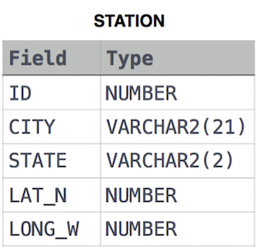
where LAT_N is the northern latitude and LONG_W is the western longitude.

Sample Input

Let's say that CITY only has four entries: DEF, ABC, PQRS and WXY

Sample Output

ABC 3
PQRS 4
Explanation
When ordered alphabetically, the CITY names are listed as ABC, DEF, PQRS, and WXY, with the respective lengths 3,3,4 and 3. The longest-named city is obviously PQRS, but there are 3 options for shortest-named city; we choose ABC, because it comes first alphabetically.

